**Instructions&Checklist for appearing in Online Examinations and procedures**

1. **Silicon Institute of Technology Online Examinations:**

The End-term Examinations for autonomous batches are going to be conducted through a remote-proctored mechanism. The candidates are required to take the examination with utmost solemnity, observing proper ethics and ensuring that all the instructions are strictly followed. SIT reserves the right to disqualify any candidate who is found to be indulging in any sort of malpractice.

To appear the online examination, a student will require to have two devices:

1. Device-1: This shall be a smart phone with front camera and shall be used for proctoring (invigilation) only.
2. Device-2: This should be preferably a desktop/laptop which will be used for accessing the question paper. If a desktop/laptop is not available, then another smart phone can be used.
3. Both devices must be connected to the Internet.
4. **Basic Instructions for appearing in the examinations:**

* Candidate is required to be seated in a proper place with sufficient light.
* Keep the Device-1 smart phone (proctoring device) in a position so that the student, the table top, writing board, papers are properly visible through the camera.
* Access the question paper through the Device-2 (desktop/laptop/smart phone).
* Use standard A4 size paper (25 pages max) to write the answers.
* A margin of 1 inch should be kept on left and top. No margin is necessary on right and bottom.
* Each page should be numbered on the top-right corner of the page.
* After completing writing all the answers, the student will use the back camera of Device-1 to capture the photos of the pages (in proper order) and upload to the system.
* Both the devices should have sufficient charge and/or connected to a charger/power outlet so that there is no disruption in the middle of the examination.
* No other books, notes, materials, etc. are allowed.
* Candidate should not write name, roll number or any other identification on the answer paper.
* If a student moves or blocks the camera, then the system will sense it and mark as malpractice.
* If a network disruption happens, a student can reconnect within 15 minutes; otherwise the system will take it as “left the exam hall”. If multiple disruptions happen, then the total time shall not be more than 15 minutes.
* Candidate will not be allowed to appear for the examination if s/he is delayed by more than 10 minutes. For example, if the exam start time is 10am, then one can appear latest by 10:10 am.
* Candidate should connect to the helpline numbers in case of any issues only prior to the exam; helpdesk support details will be shared later

1. **Infrastructure Required to Take the Examination:**

**Device-1**: A smart phone with Android 5.0 or later, preferably with 4GB RAM with front and back camera. The examination app installation will be provided by Exam Section. The device should be connected to the Internet.

**Device-2:** A desktop/laptop with Intel P5/Core i3 or above and Windows 7/8/10 or Ubuntu 14.1/16 Operating System, 2GB RAM or more. It need not have a webcam. Latest Chrome/Firefox browser should be there. The device should be connected to the Internet. In absence of a desktop/laptop, another smart phone with the same or little lower configuration as Device-1 can also be used.

**Important Note:**

* Candidate must login on Device-1 before 30 minutes of the scheduled time of the examination.
* Live Proctoring must be started after logging in, and the Device-1 should be positioned properly as described above.
* After logging in to Device-1 and starting the live proctoring, the candidate can login into Device-2 to access the question paper.

# Online Mock Exam Procedure:

**Setup Before Exam:-**

1. **For Live Proctoring:-(Device-1: Android Mobile)**

* Download updated zoom application and Install it.
* Sign up zoom and make sure your display name must be your SIC No.
* Don’t turn off the video in zoom settings.
* Install proctoring app in your device-1(mobile)

1. **For Appearing Examination:- (Device-2: Laptop/Android Mobile)**

* Install/update latest version of chrome browser
* Allow camera & pop-up.

**During Exam:-**

**Step: 01 -For Live Proctoring (Device-1: Mobile)**

* Open Proctoring mobile app installed before the examination.
* Enter your user Id i.e. SIC No. & password
* Please select your organization as “**Silicon institute of Technology, BBSR**” from the dropdown in the ‘***Select Organization****’* tab.
* After successful login, you will be asked for photo validation.

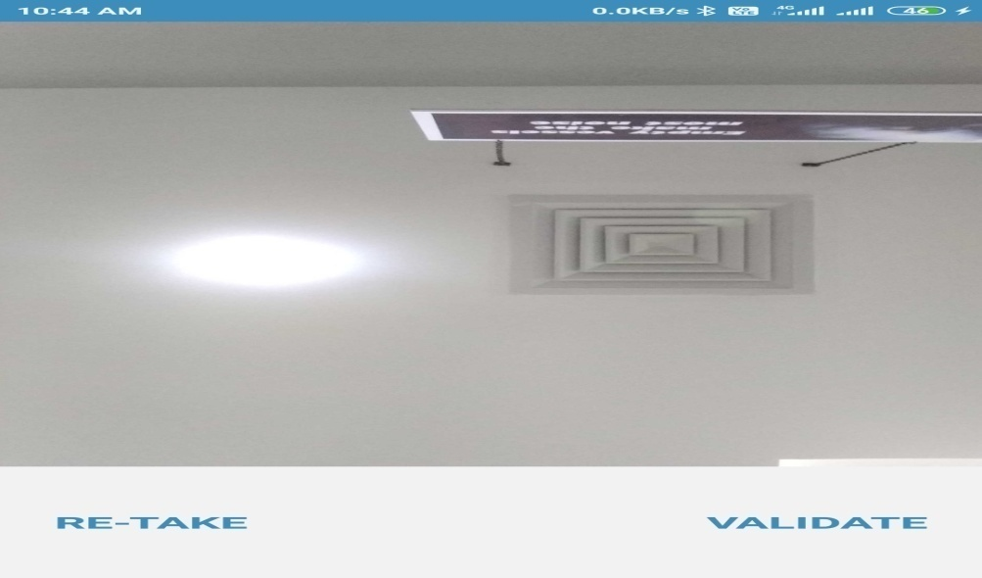

* Candidate has to validate his/her photo by click on the button “take photo”.
* Next click on “validate’’ button.
* The instant captured photo will be matched with profile image.
* After successful match, candidates will be allowed to enter Exam Room/proctoring room.
* If no photo matched, then at least try 3 times, then wait for approval.
* After successful photo validation, exam name will be displayed in the screen and click on “join exam room/join proctoring” button.

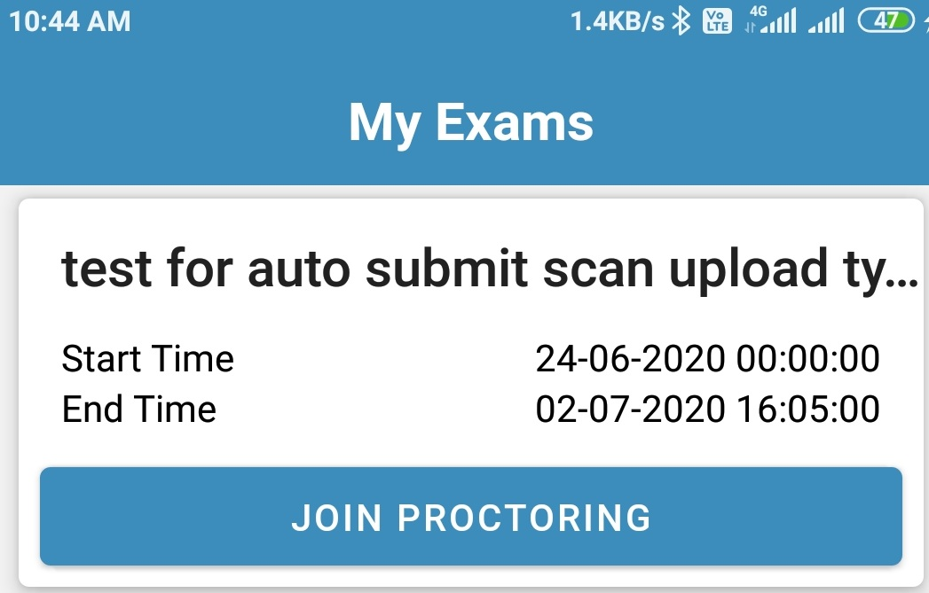

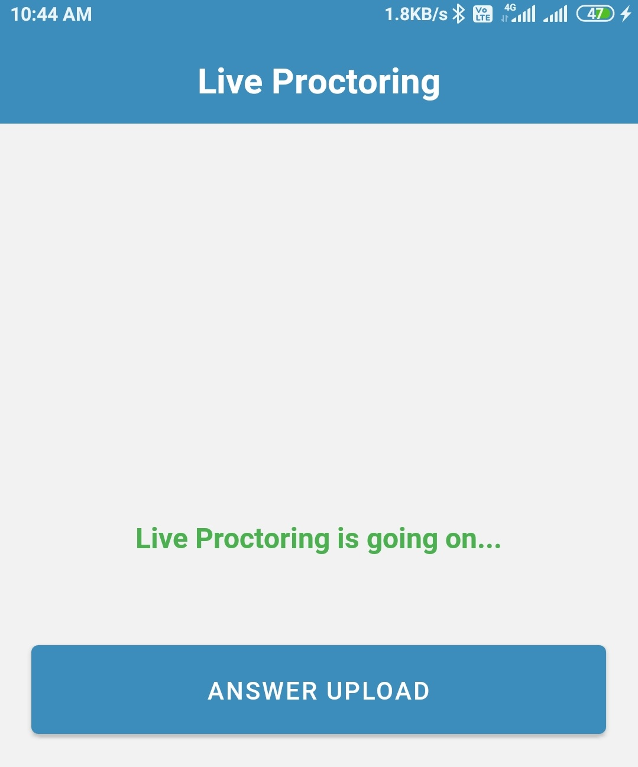

* A new page of zoom application will open and join with video on mode.
* Keep this proctoring device in such a place that it will display your picture with writing table-top and the other device (Device-2) clearly.
* There will be other students in the same exam room. You should not waste time seeing other’s videos or try to talk with others. Such actions will be captured by the system.

**Step: 02-For Exam appearing (Device-2)**

* Open latest version of chrome browser and open the url<https://liveexam.edusols.com>.
* Login by using your user ID (SIC No) and password.
* For 1st time user use password as “password” and it will ask you to change your password.

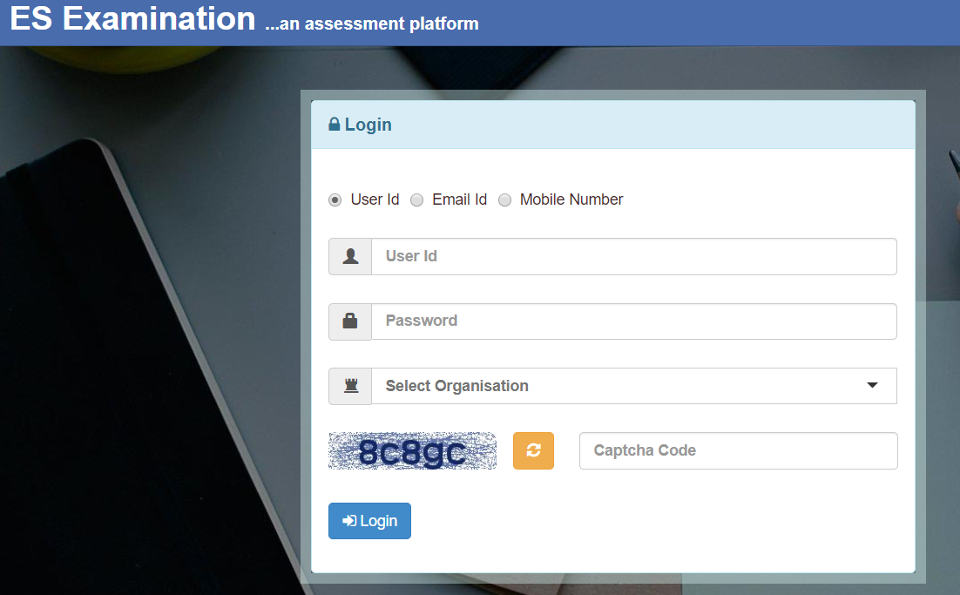

**After Login:-**

1. **Exam Attempt:**

* Click on the ‘***Attempt***’ button for the exam shown. If you have exceeded the maximum allowable entry time for appearing the exam, then you can not appear the exam.
* Similarly if you have not joined the Exam Room/proctoring room in device-1, then you will be not allowed to appear the exam.

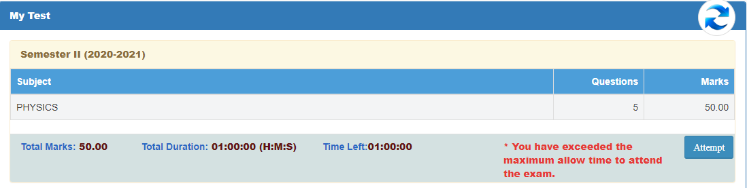

* Write the answers in plain papers against each questions displayed in the exam screen.
* Use a new sheet for answering a fresh question.

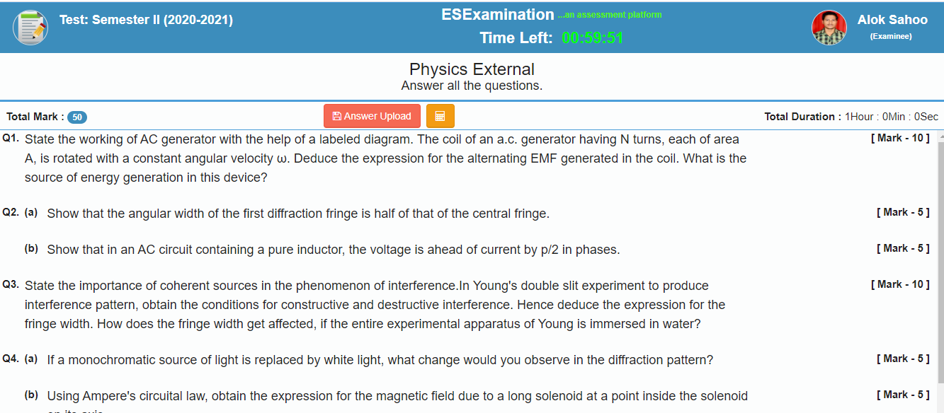

* Your exam will be completed once time will over or you will click on the answer upload button shown in the above screen.Don’t operate this screen further.
* Then go to Device -1

1. **Answer Sheet upload: ( By Proctoring Device-1)**

* Now open the minimized proctoring application in the device-1.
* Click on “answer Upload button” shown in the application.
* Take photo from the device and upload the answer sheet with in the specified time.
* 

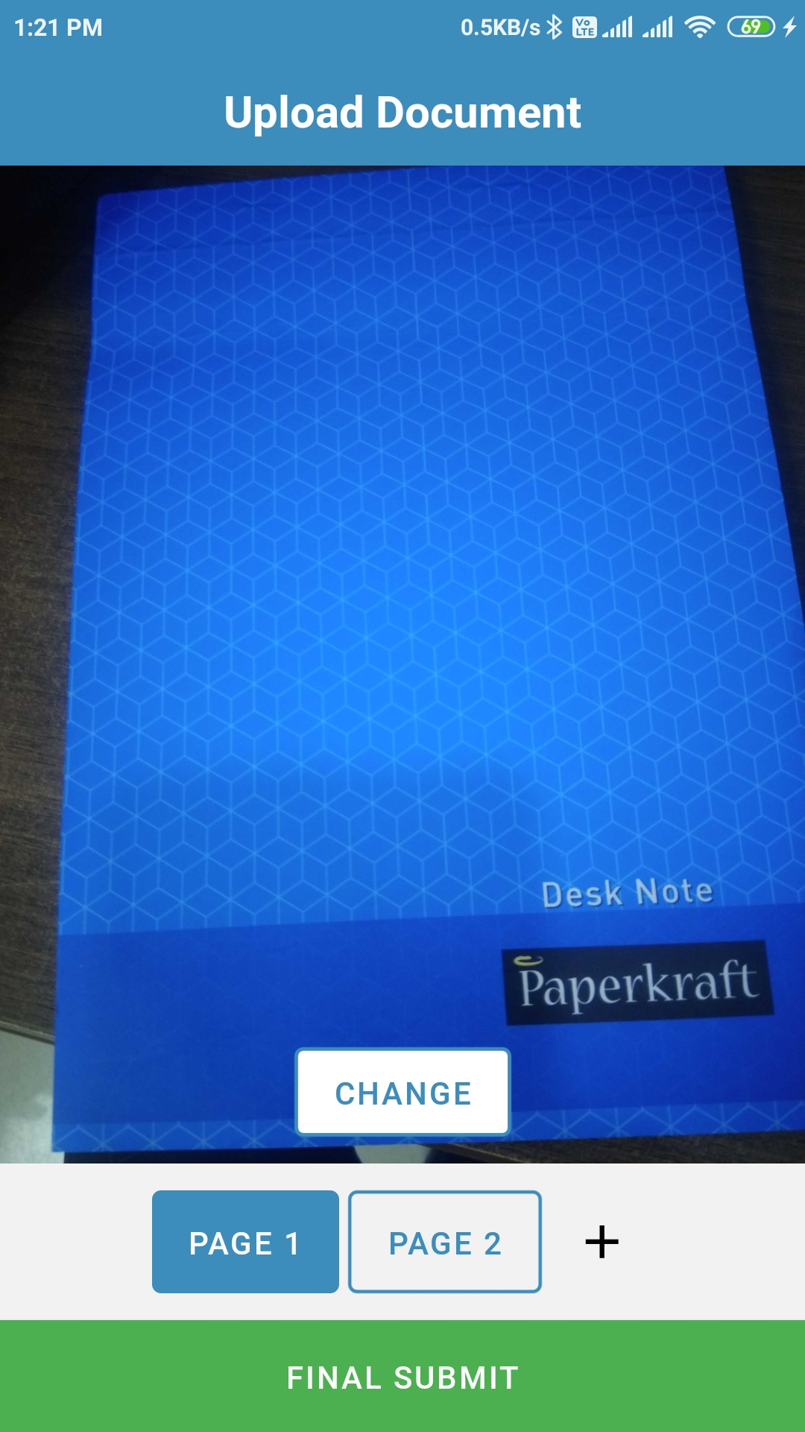

**Helpline Numbers:**

**Mr. Sushant Pattanayak (9437082906)**

**Mr. Chittaranjan Mohapatra (9938068640)**

**You may also call your Faculty Adviser if the above numbers are busy.**